**HACKATHON ’23 SEASON 2**

**BIT REBELS (ADVANCE LEVEL)**

|  |  |
| --- | --- |
| Mohit G Dodeja (7th Sem) | Stuti Mittal (7th Sem) |
| Kripalsinh Solanki (7th Sem) | Jainam Shah (7th Sem) |

To encourage a strong sense of community among book lovers, we propose a collaborative platform for a distributed library services where users can share their book collections for lend or sale as well as borrow or buy from fellow subscribers. Users will have the ability to handle transactions with buyers directly through the platform. The platform will also feature a robust search functionality to help users find books of interest. To ensure privacy and confidentiality, the platform will safeguard user data and personal information. We encourage teams to use AI and advanced algorithms to offer creative solutions to have the best engagement on the platform.

**Required MVPs:**

* User Registration and Profile
* Book Listing and Management
* Lend/Sales and Borrow/Buy
* Book Search and Discovery
* Book Delivery Options
* Platform Fees

ABSTRACT

**BR Lib** provides book lovers a platform to buy/sell/lend/borrow their books. User to user interaction makes the process extremely transparent. Users can directly contact with the owner and can also get their desired book by searching them. Each of them gets a unique profile that represents their book-data.

SOLUTION

**Flow:**

The making of the flow was itself a journey. The destinations involved in the route were as follows:

1. **Starting with brainstorming:**

Initially the team had a detailed discussion over the interpretation of their own individual perspectives on the problem statement, after which to arrive to a common direction (Making sure that everyone was on the same page).

Once the direction was clear, roles were assigned to the team members according to their domain specifications, including UI/UX design, front-end & back-end development, database management as well as documentation that went parallelly throughout the project.

1. **Discussing elements and relationships**

Following are the elements and their implementations:

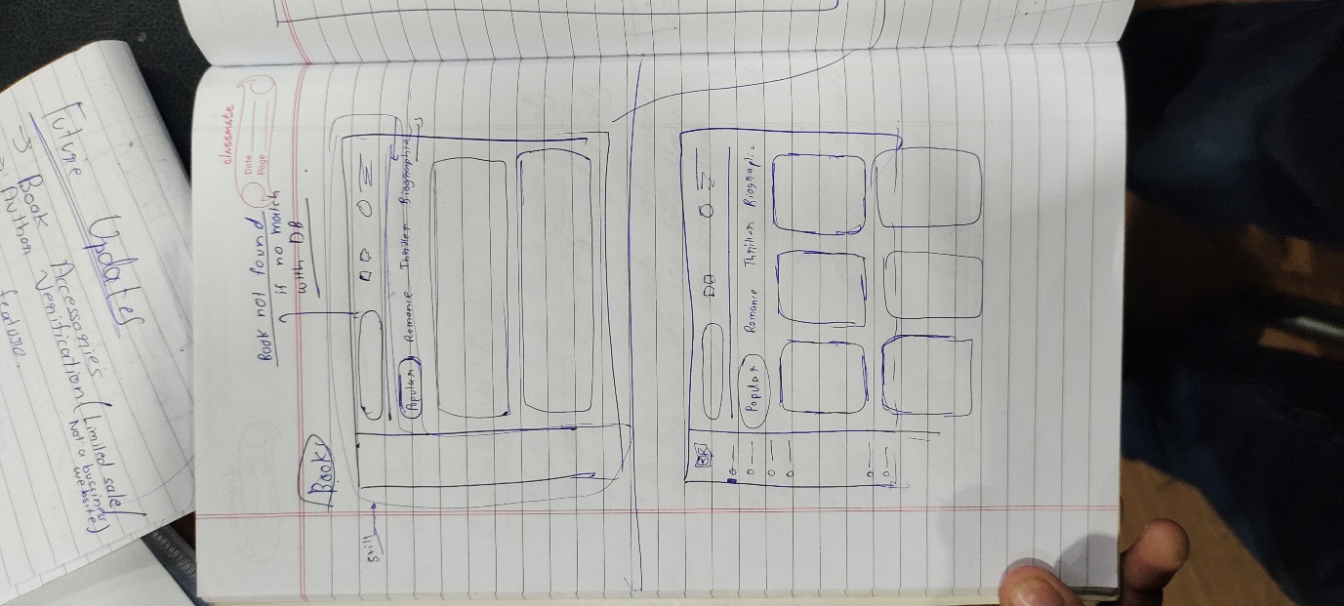

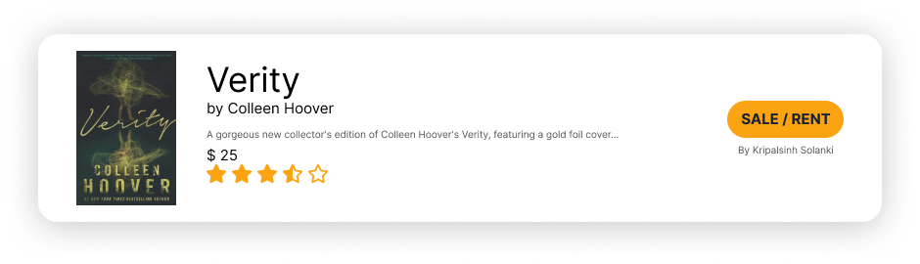



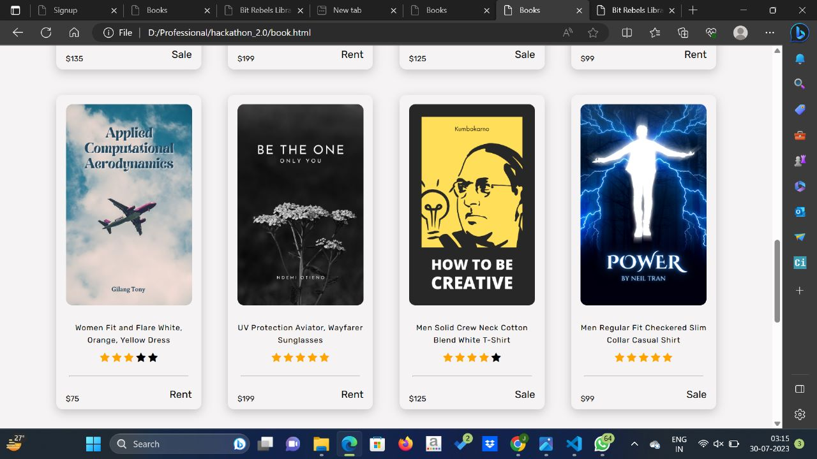

1. **Discussing themes**

Design Inspiration:

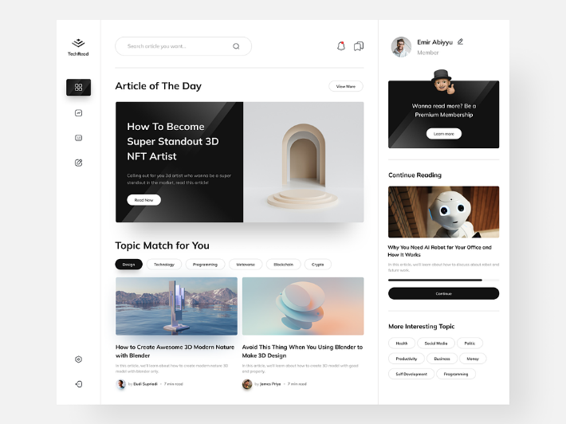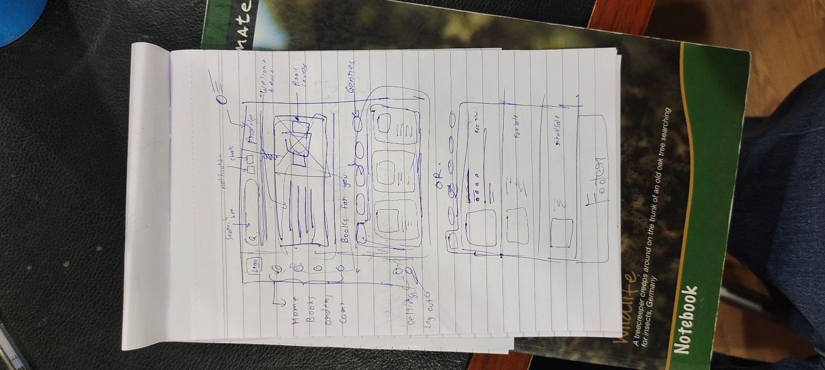

1. **Execution:**

**Tools and Resources:**

**Designing:** Figma (UI/UX and wireframing),

**Frontend:** HTML, CSS

**Back-end/Database:** Google Firebase

1. **The Backend issue:**

**Approach:** Our initial approach involved using of **NodeJs** and create the Database in **MongoDB**.

But as soon as we connect the database to the login page and signup page the system gets crashed. But the hurdle we faced was, the system failure as soon as one tries to Log In/Sign Up. Multiple attempts were made throughout the session, but the results won’t differ. As a result, we decided to focus on the strong points of our project i.e., UI and front-end.

1. **Timeline:**

Goals according Based on timelines were set. Which were as follows:

* Initial **3 hours** involved the brainstorming and work assigning. The **Log In/Sign Up** page along with their design, front-end and back-end were also completed during this interval.
* After which, the next few hours went on developing the **website** according to the provided instructions. That went on till **7 P.M.** in the evening.
* Few hours were spent on checking of the possible designs and approaches that unfortunately didn’t work and hence **significant changes** were made accordingly. That went on for **10 P.M.**
* By **12:30 P.M.** we had our **front-end layout** for the whole site ready and the work for **back-end** went on for the night.
* Next morning, the **documentation** part was done along with the **ppt** with all the work we could gather in the given time period.

1. **The final flow:**

Above is the flow of a user from the home page to logging in/signing up, looking for books, purchasing/renting them, posting your own books for sale/rent. There is a navigation bar through-out the site, that helps users navigate through pages like – HOME, BOOKS, PLACED ORDERS, CART. Profile menu especially helps user to add book for sale/rent with any relevant amount they want, creating an environment amongst the users.

1. **Future additions:**

Apart from the provided services, there were some features that might not have been reached in the due time. But they can surely be implemented as an update that are extremely beneficial to the subscribers and the company itself too. Out of which, some of them are:

* **Secure Chat Feature** 

Users will be able to chat with the respective owners of the books and authors as well (If they permit). This will all be cloud based encrypted chat and won’t require any personal contact details which becomes favourable as we don’t want to share them publicly with a stranger.

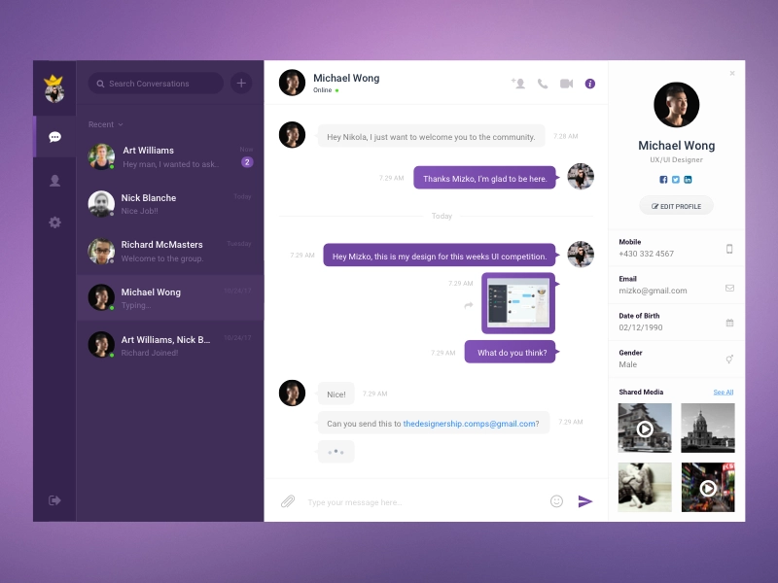

* **Author verification** 

Authors can get verified with required documents which would help them get the recognition they deserve.



The descison regarding whether the signing in usre is a reader or an author will be done when they sign up for the first time, an aditional question is added:



* **Other Book Accessories: **

This can be a great business approach for the website as the people coming to the website are regular readers who might find these accessories interesting and purchase the wide range of products available on the BR Store:

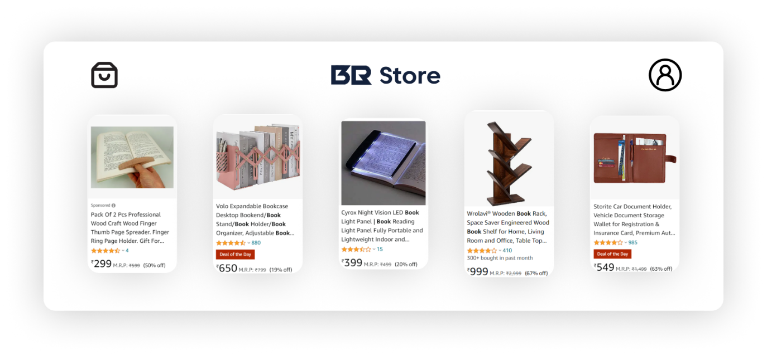

1. **Conclusion:**

As the back-end issue remained unsolved, we had our front-end and UI ready as the submission assignment. Which actually helped us improve the UI as better as possible and provide the website user an engaging experience along with durable services that would surely make them come back to the site in future as well.

The Interface also helps for the marketing due to the word of mouth.

Hence, hereby we conclude our report.

**Thank You**